CREATE TABLE Employee (

Emp_id INT PRIMARY KEY,

Emp_name VARCHAR(50),

Dept VARCHAR(50),

Salary DECIMAL(10,2)

);

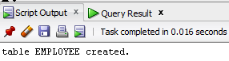

INSERT INTO Employee VALUES (1, 'David Smith', 'Marketing', 7500.00);

INSERT INTO Employee VALUES (2, 'Olivia James', 'HR', 6900.00);

INSERT INTO Employee VALUES (3, 'Charles Brown', 'Sales', 7200.00);

INSERT INTO Employee VALUES (4, 'Alice White', 'Production', 6800.00);

INSERT INTO Employee VALUES (5, 'Daniel Craig', 'Production', 7100.00);

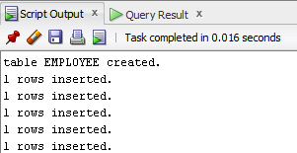

SELECT * FROM Employee WHERE Salary > 7000;

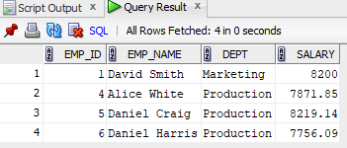

UPDATE Employee SET Salary = 8200.00 WHERE Emp_name = 'David Smith';

INSERT INTO Employee VALUES (6, 'Daniel Harris', 'Production', 6700.00);

DELETE FROM Employee WHERE Emp_id = 3;

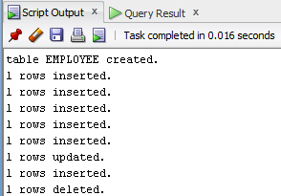

SELECT * FROM Employee WHERE Emp_name NOT LIKE 'D%' AND Emp_name NOT LIKE 'O%';

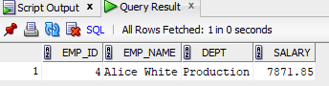

SELECT Dept, SUM(Salary) AS Total_Salary FROM Employee GROUP BY Dept;

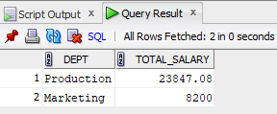

UPDATE Employee

SET Salary = Salary * 1.05

WHERE Dept = 'Production';

DELETE FROM Employee WHERE Salary < 7000;

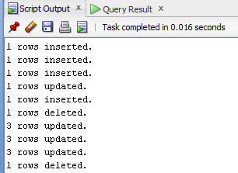

SELECT Emp_name, Salary

FROM Employee

WHERE Salary = (SELECT MIN(Salary) FROM Employee);

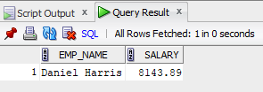

UPDATE Employee

SET Salary = 8200.00

WHERE Dept = 'Marketing';

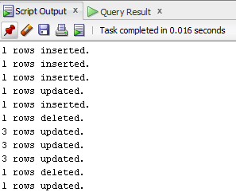

SELECT Emp_name FROM Employee WHERE Emp_name LIKE 'A%';

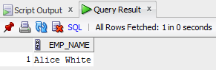

SELECT Emp_name FROM Employee WHERE Emp_name LIKE '%it%';

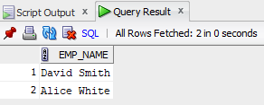

SELECT DISTINCT UPPER(Dept) AS Department FROM Employee;

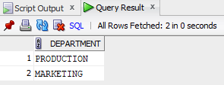

SELECT * FROM Employee WHERE Dept LIKE 'M_r%' AND Dept LIKE '%ket%';

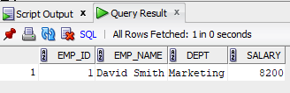

SELECT DISTINCT UPPER(REVERSE(Dept)) AS Reversed_Dept FROM Employee;

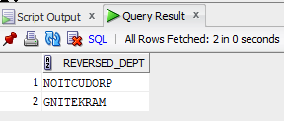

**OUTPUT**

